**Analyzing the Performance And efficiency Of the Radisson Hotels using Data Visualization techniques**

**1.INTRODUCTION**

A hotel is a place where bonfire traveller can receive food and shelter, provided she/he is in a position to pay for it and is in fit condition to be received. Inns –Public houses in early times in England were called inns.

**1.2 PURPOSE**

At Radisson Hotel Group we strive to be the first choice in the mind of guests, owners and talent. In our journey to achieve this, we practice strong beliefs and actions that respect the diversity of people, the community, ethics and the planet.

**2 PROBLEM DEFINITION AND DESIGN THINKING**

**How To You Analyze financial performance of a hotel ?**

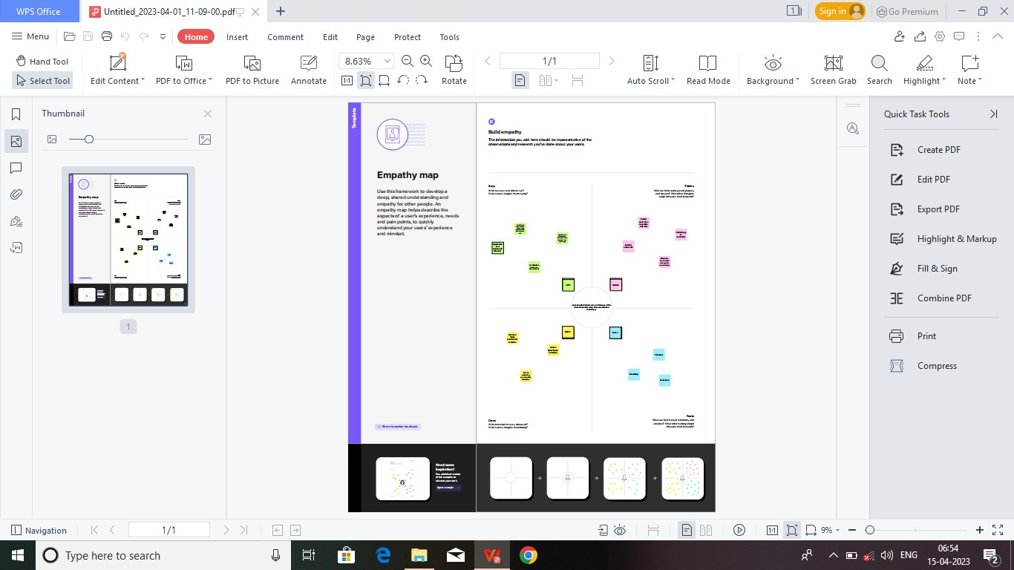

**2.2 IDEATION & BRAINSTORMING MAP**

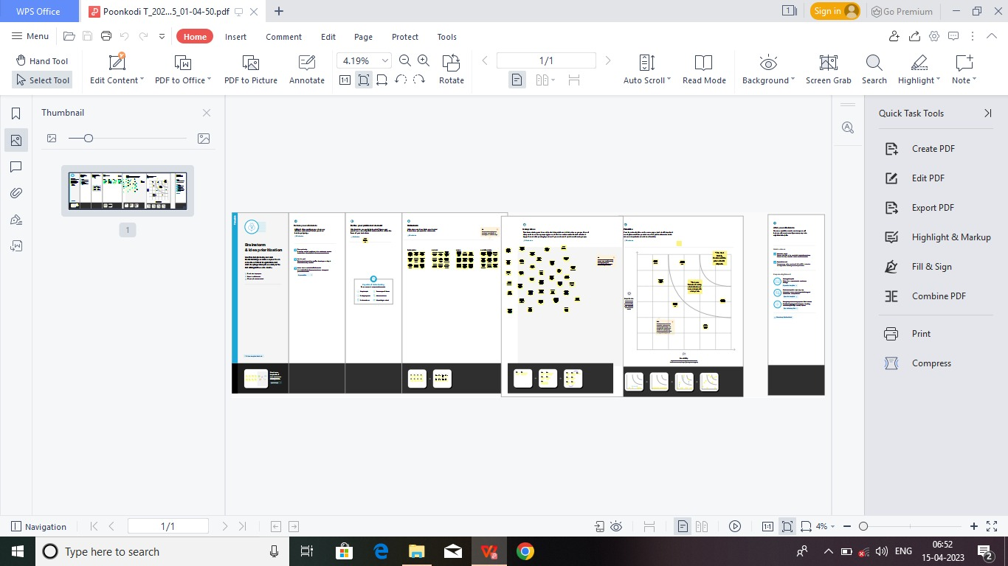

**2.2 IDEATION & BRAINSTORMING MAP**

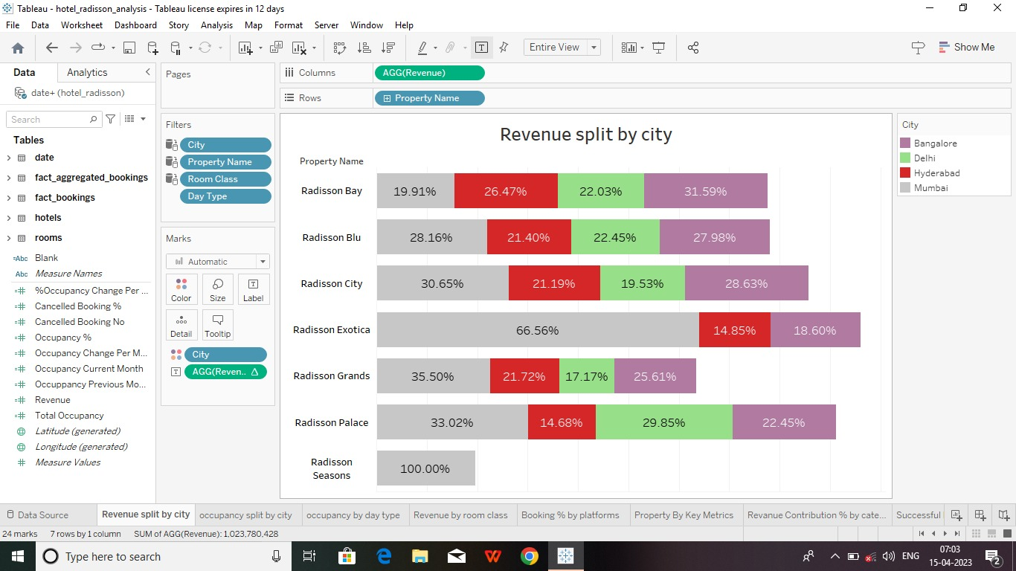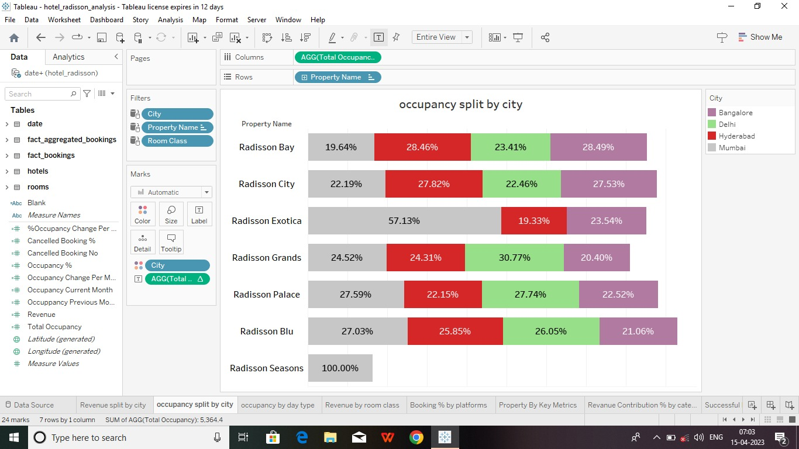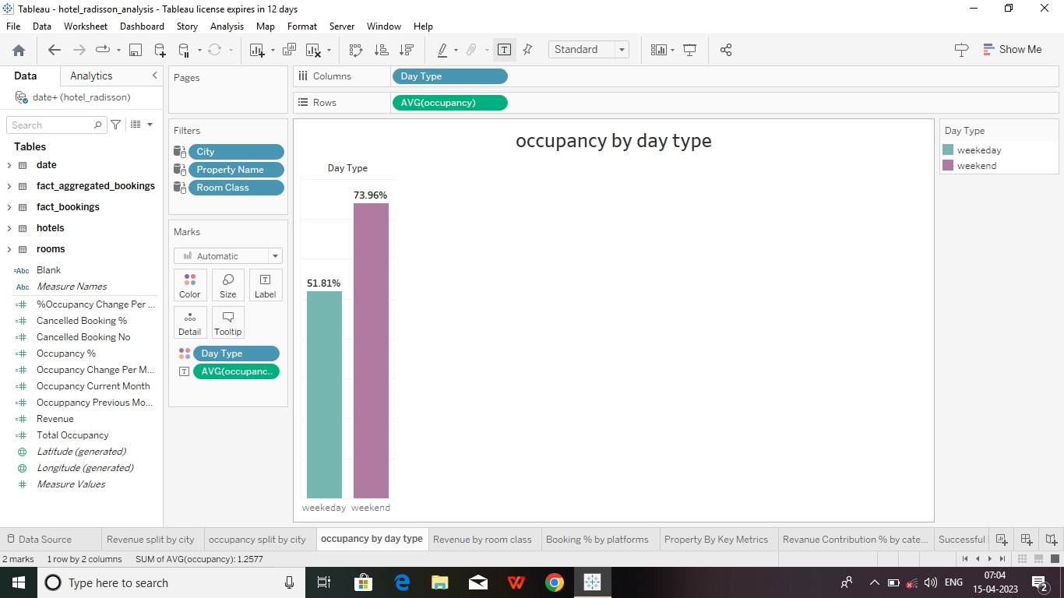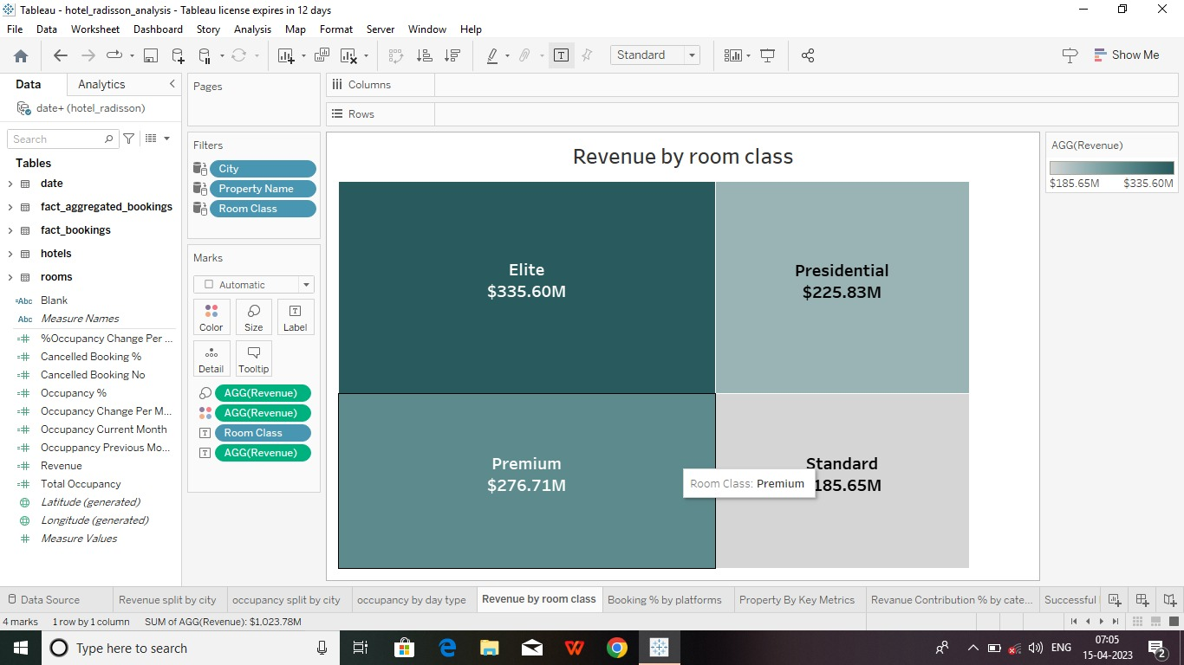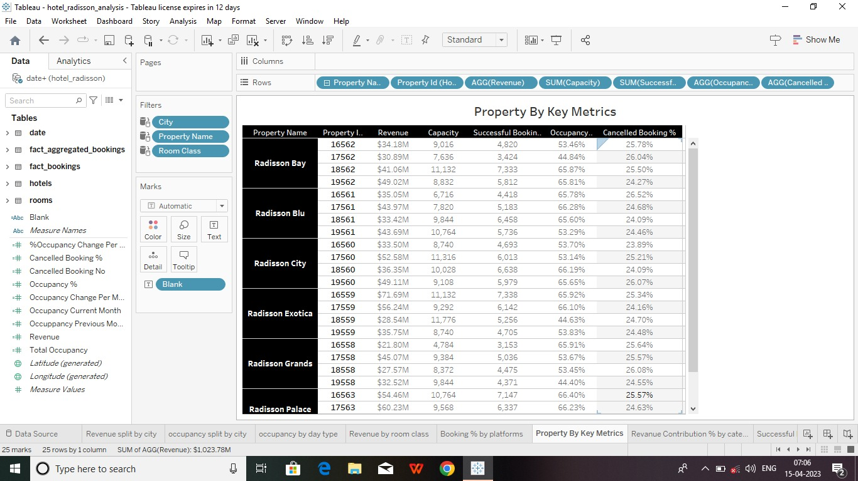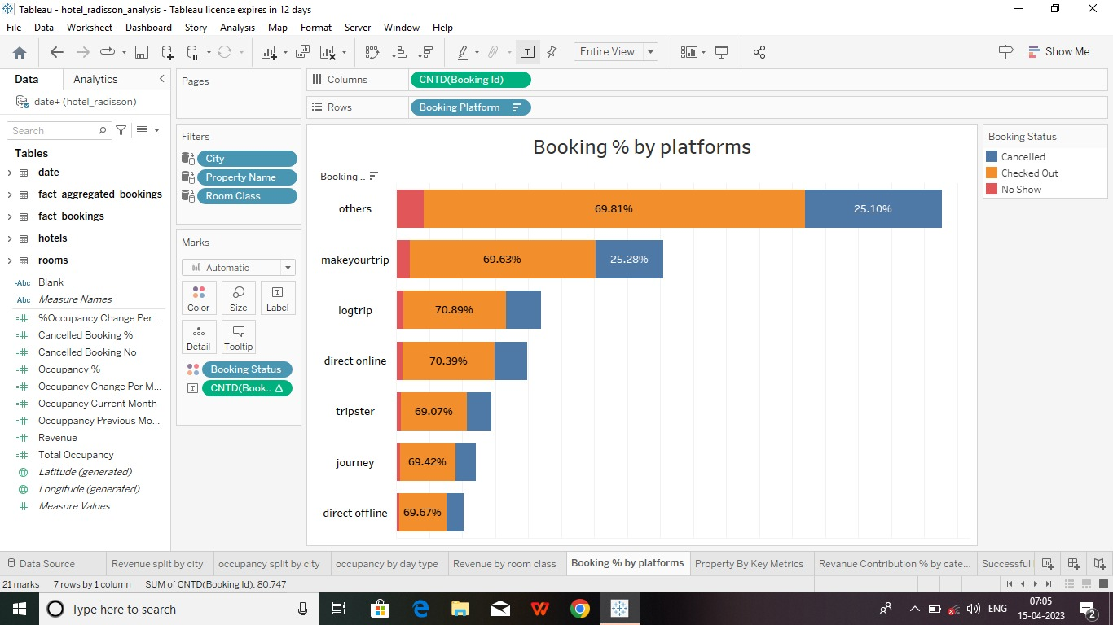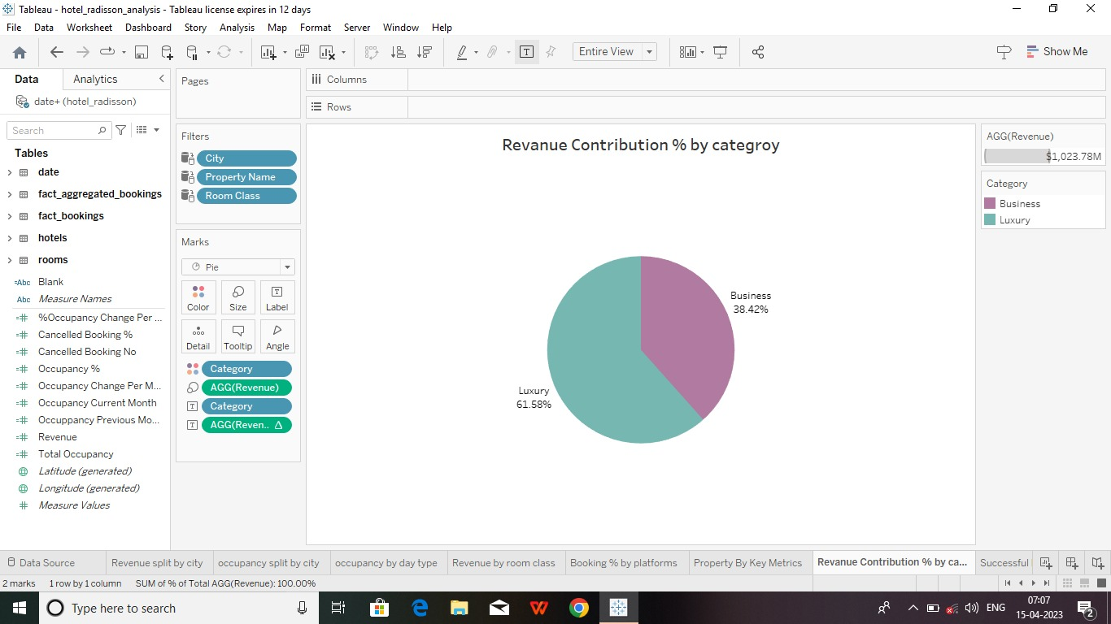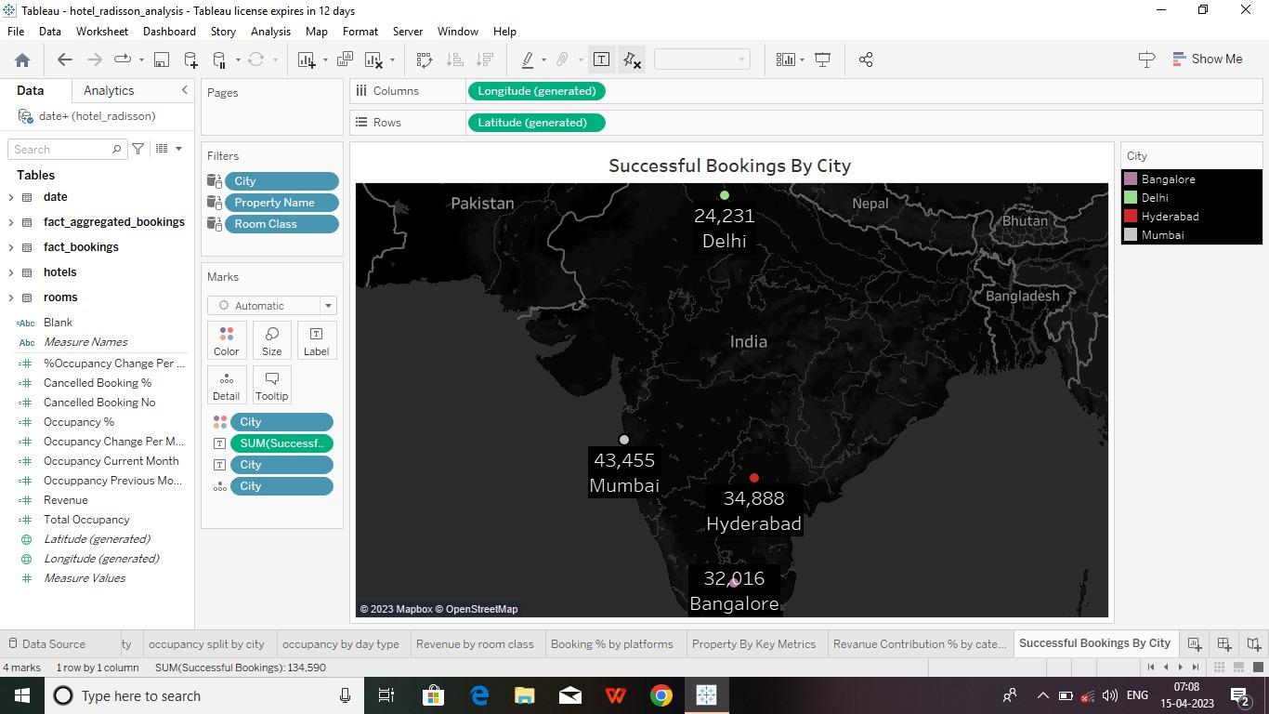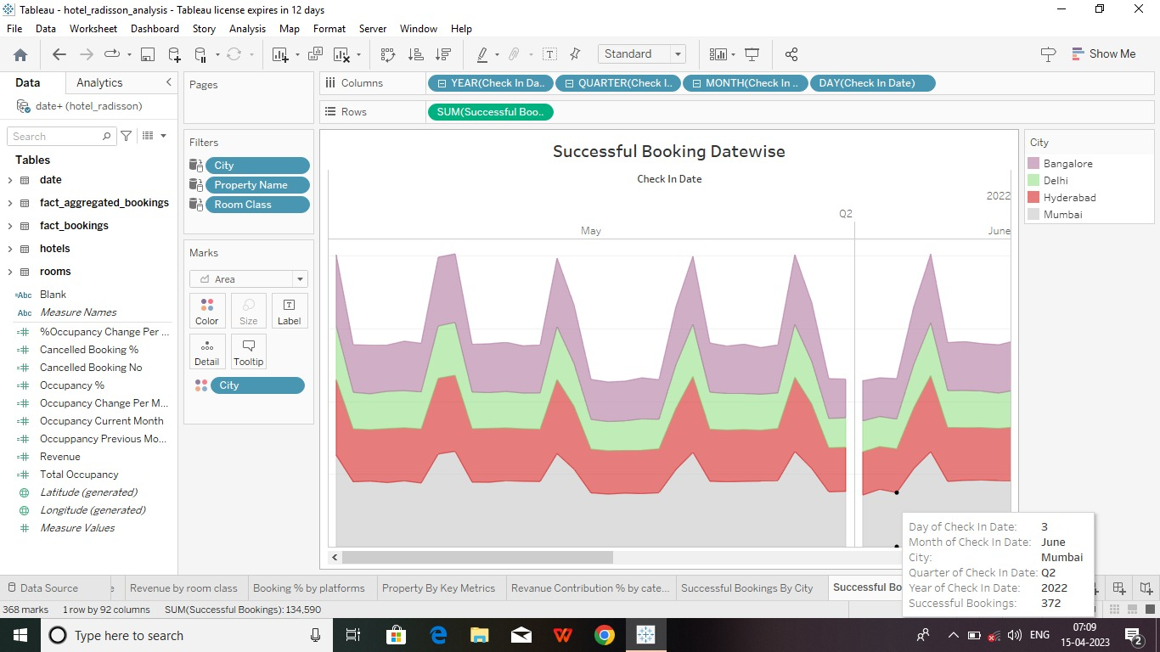

**4 ADVANTAGES & DISADVANTAGES**

Employees at Radisson Hotels rank their Perks and Benefits lower than most, ranking them in the Bottom 5% of all similar sized companies with 501-1,000 Employees on Comparably.

The Operations department and African American/Black employees at Radisson Hotels rank their Perks and Benefits the highest, while Caucasian employees and employees with Over 10 Years experience rank the Perks and Benefits at Radisson Hotels the lowest against other demographic groups at the company.

**Disadvantages**

* The brand name comes with a perception of being expensive.
* Current economic status is bound to take a toll on spending power.
* Still trying to establish itself in the emerging economies.

**5.APPLICATION**

Applying for a job in hotel or restaurant management requires a personable nature, attention to detail and the ability to project confidence. The letter you draft in conjunction with your job application should demonstrate that you're articulate, knowledgeable and have the ability to be engaging with customers and staff.

**6 CONCLUSION**

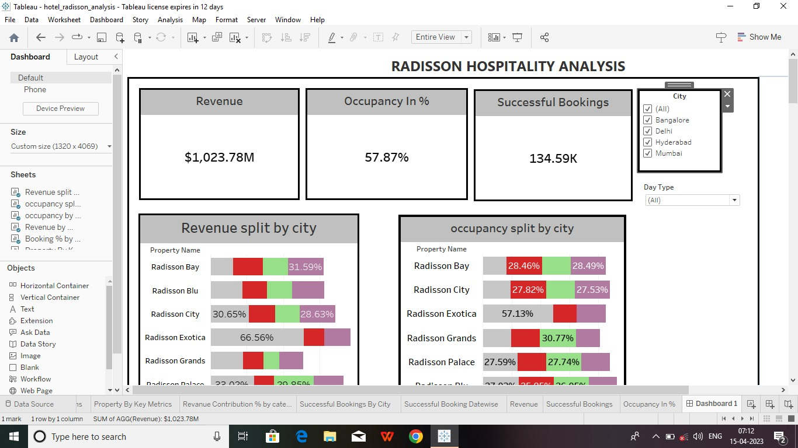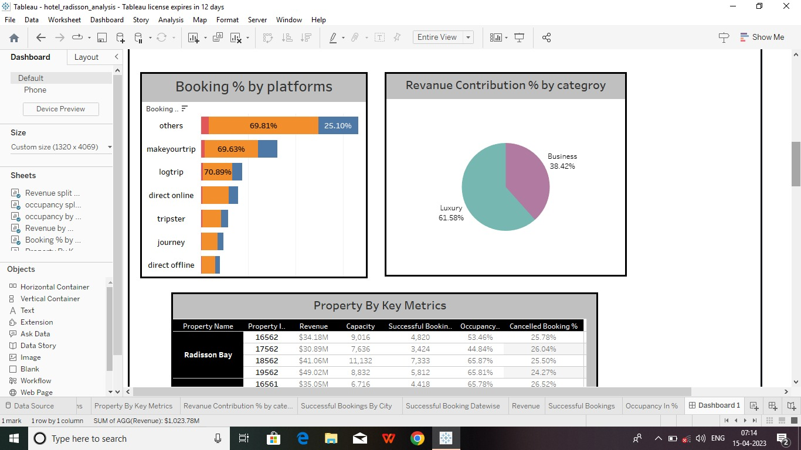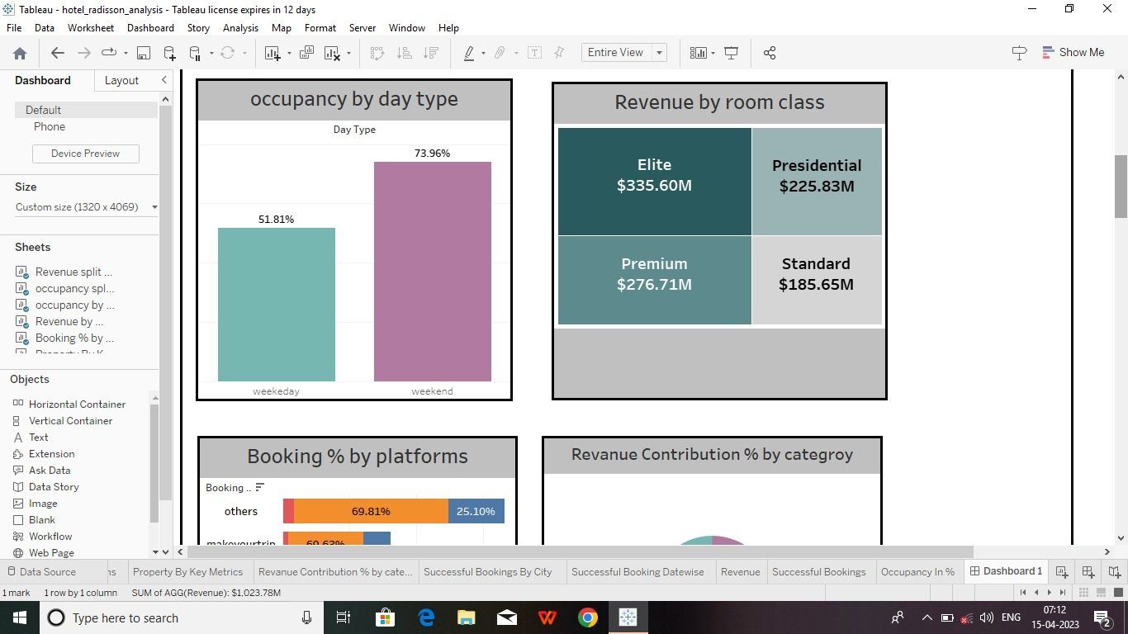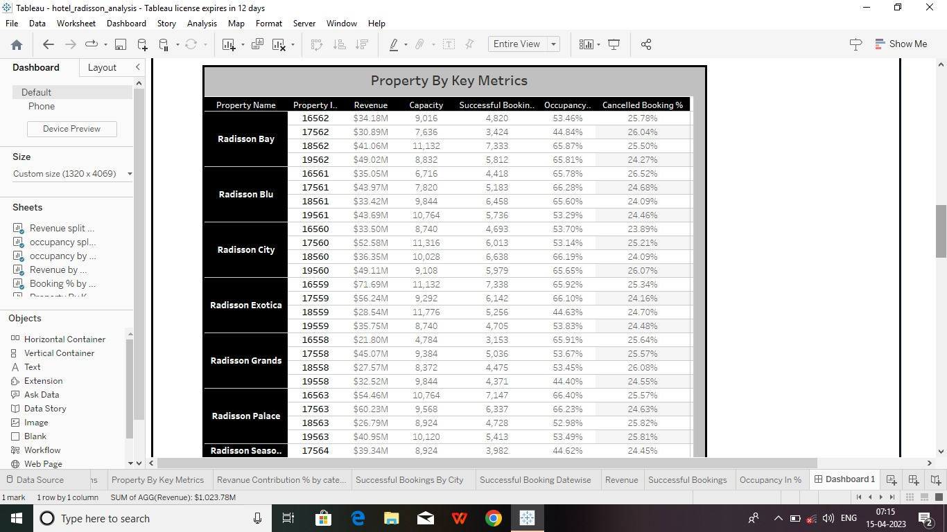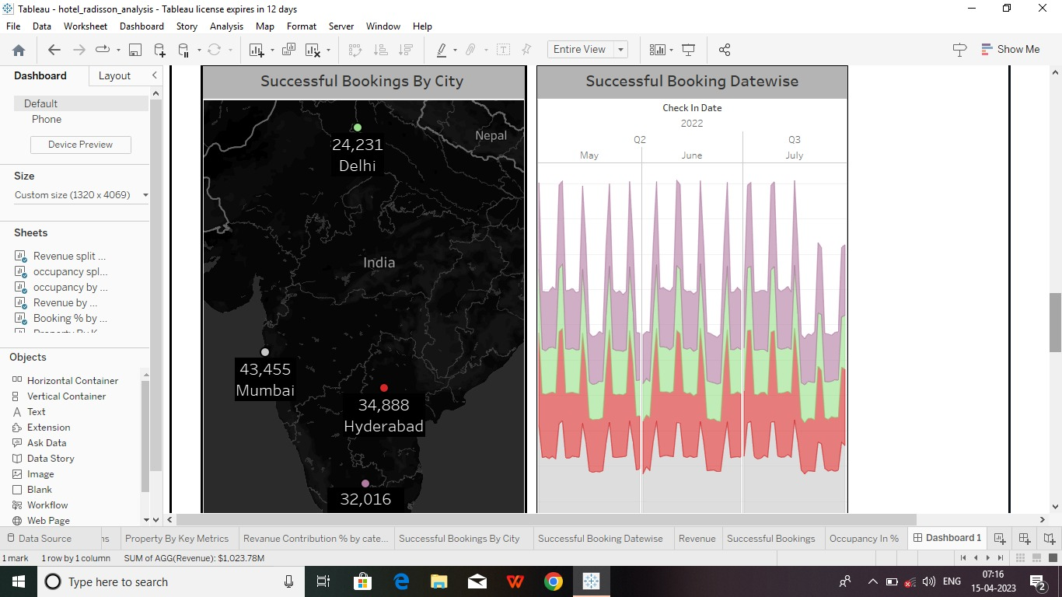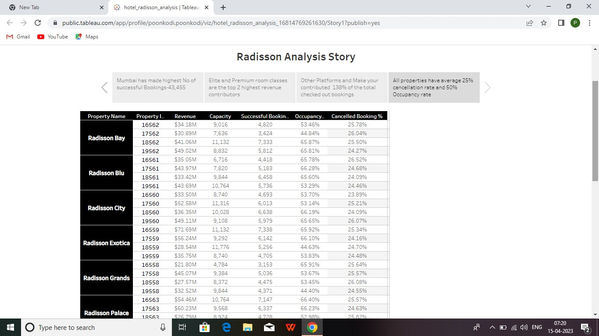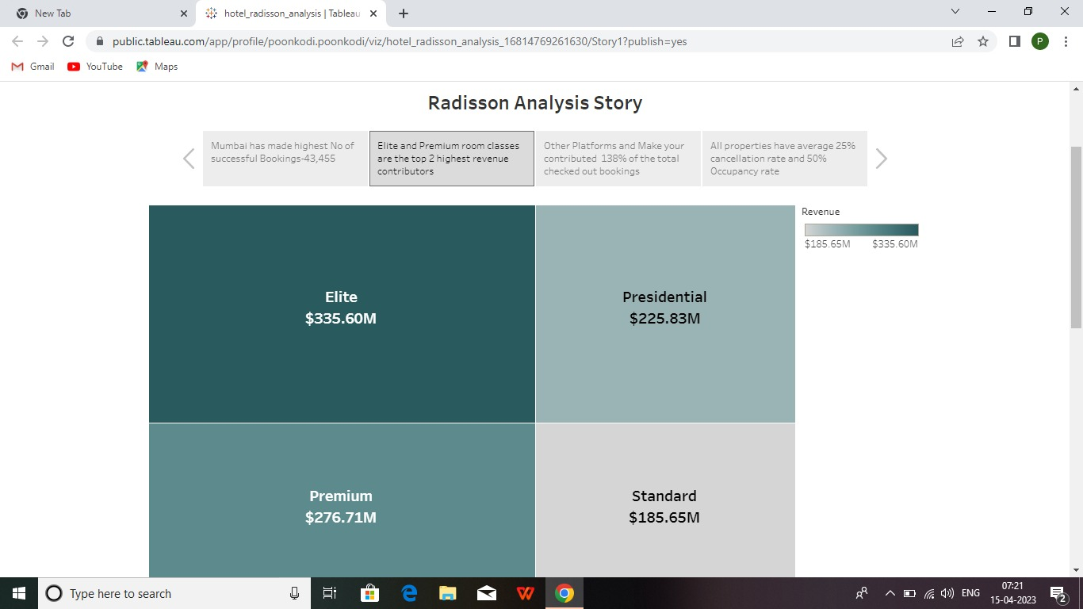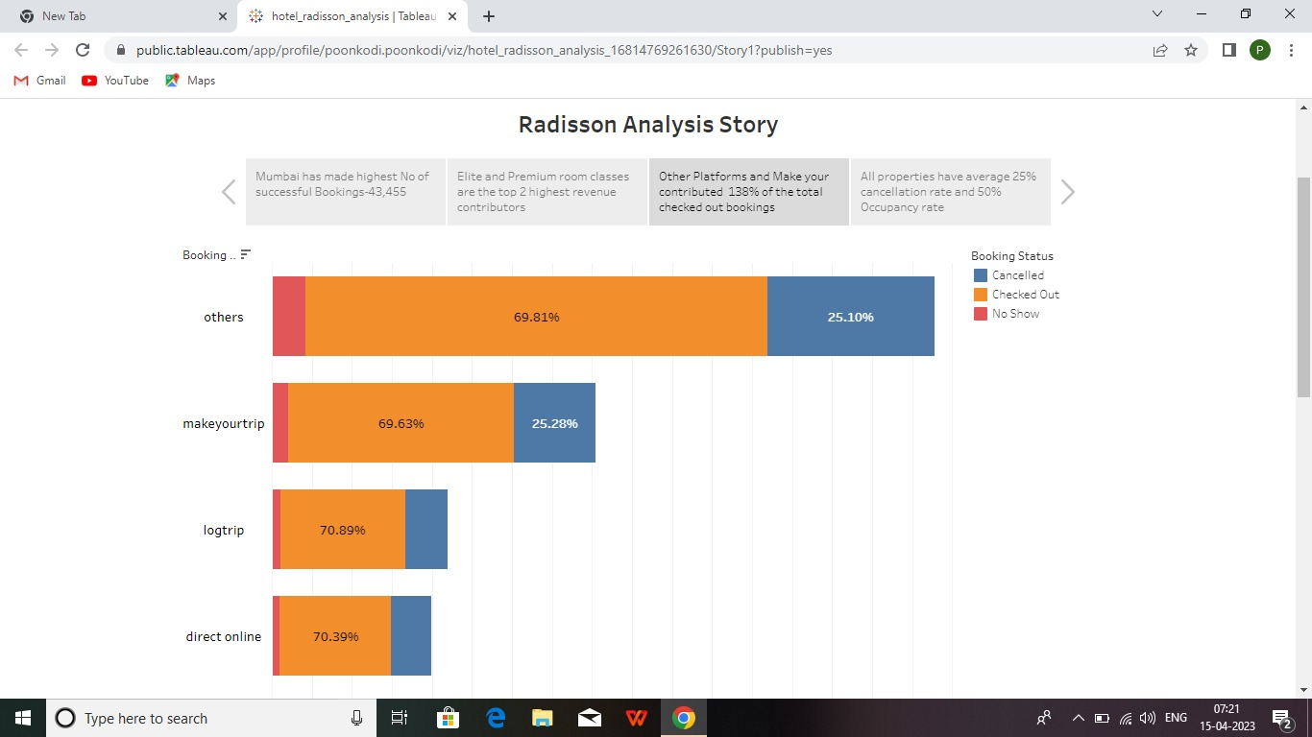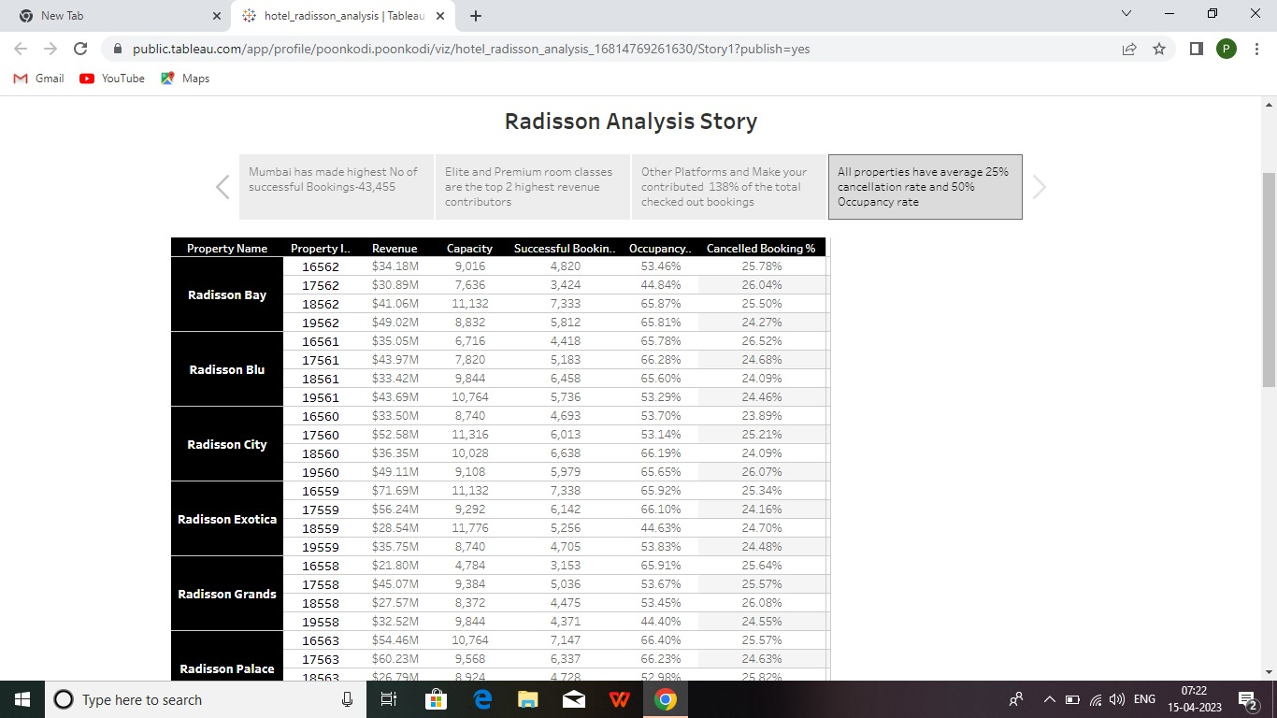

**7 FUTURE SCOPE**

With the escalating demand of hotels in India, the hotel management industry has huge growth potential in the near future. The demand for smart and skilled professionals in this industry is growing at a fast pace, not only in India but also worldwide.

There is a dire need for skilled and retainable professionals. In this era of social media, everyone is aware of what to expect in a hotel and the standards one needs.

Advanced technologies are introduced in the industry such as Mobile door key instead of plastic cards, Mobile hub spots where everything in the room can be controlled by one remote room phone. Faster Wi-Fi’s having better bandwidths.

These technologies will revolutionalize the hotel industry to the next level. As technology innovations continue to transform every industry and job role, the hotel managing industry is certainly no exception.

In the near future automation will be a great part of hotel management industry too: Speak to order platforms will be trendy by which a virtual assistant will manage everyday mundane tasks, such as taking simple food orders and explain all the queries a customer has.

Cloud services will be available such that a person will have entertainment on tap. You no longer have to visit restaurants anymore, the food and services you need will avail to you at home, ordering food online has become a recent update provided.

The hotels will help us in having a smarter and meaning experience in the next decade.

**8.APPENDIX**

**Source Code:** Dashboard

**<div class='tableauPlaceholder' id='viz1681611029998' style='position: relative'><noscript><a href='#'><img alt=' ' src='https:&#47;&#47;public.tableau.com&#47;static&#47;images&#47;ho&#47;hotel_radisson_analysis_16814769261630&#47;RadissionHospiutalityanalysisdashbord&#47;1_rss.png' style='border: none' /></a></noscript><object class='tableauViz' style='display:none;'><param name='host_url' value='https%3A%2F%2Fpublic.tableau.com%2F' /> <param name='embed_code_version' value='3' /> <param name='site_root' value='' /><param name='name' value='hotel_radisson_analysis_16814769261630&#47;RadissionHospiutalityanalysisdashbord' /><param name='tabs' value='yes' /><param name='toolbar' value='yes' /><param name='static_image' value='https:&#47;&#47;public.tableau.com&#47;static&#47;images&#47;ho&#47;hotel_radisson_analysis_16814769261630&#47;RadissionHospiutalityanalysisdashbord&#47;1.png' /> <param name='animate_transition' value='yes' /><param name='display_static_image' value='yes' /><param name='display_spinner' value='yes' /><param name='display_overlay' value='yes' /><param name='display_count' value='yes' /><param name='language' value='en-US' /></object></div> <script type='text/javascript'> var divElement = document.getElementById('viz1681611029998'); var vizElement = divElement.getElementsByTagName('object')[0]; if ( divElement.offsetWidth > 800 ) { vizElement.style.minWidth='1320px';vizElement.style.maxWidth='100%';vizElement.style.minHeight='4119px';vizElement.style.maxHeight=(divElement.offsetWidth*0.75)+'px';} else if ( divElement.offsetWidth > 500 ) { vizElement.style.minWidth='1320px';vizElement.style.maxWidth='100%';vizElement.style.minHeight='4119px';vizElement.style.maxHeight=(divElement.offsetWidth*0.75)+'px';} else { vizElement.style.minWidth='1016px';vizElement.style.maxWidth='100%';vizElement.style.minHeight='3450px';vizElement.style.maxHeight=(divElement.offsetWidth*1.77)+'px';} var scriptElement = document.createElement('script'); scriptElement.src = 'https://public.tableau.com/javascripts/api/viz_v1.js'; vizElement.parentNode.insertBefore(scriptElement, vizElement); </script>**

**Story board:**

**<div class='tableauPlaceholder' id='viz1681611295400' style='position: relative'><noscript><a href='#'><img alt=' ' src='https:&#47;&#47;public.tableau.com&#47;static&#47;images&#47;ho&#47;hotel_radisson_analysis_16814769261630&#47;Story1&#47;1_rss.png' style='border: none' /></a></noscript><object class='tableauViz' style='display:none;'><param name='host_url' value='https%3A%2F%2Fpublic.tableau.com%2F' /> <param name='embed_code_version' value='3' /> <param name='site_root' value='' /><param name='name' value='hotel_radisson_analysis_16814769261630&#47;Story1' /><param name='tabs' value='yes' /><param name='toolbar' value='yes' /><param name='static_image' value='https:&#47;&#47;public.tableau.com&#47;static&#47;images&#47;ho&#47;hotel_radisson_analysis_16814769261630&#47;Story1&#47;1.png' /> <param name='animate_transition' value='yes' /><param name='display_static_image' value='yes' /><param name='display_spinner' value='yes' /><param name='display_overlay' value='yes' /><param name='display_count' value='yes' /><param name='language' value='en-US' /></object></div> <script type='text/javascript'> var divElement = document.getElementById('viz1681611295400'); var vizElement = divElement.getElementsByTagName('object')[0]; vizElement.style.width='1016px';vizElement.style.height='1014px'; var scriptElement = document.createElement('script'); scriptElement.src = 'https://public.tableau.com/javascripts/api/viz_v1.js'; vizElement.parentNode.insertBefore(scriptElement, vizElement);**